A000-Xian-Rome-St Peter with Halo-Right Hand to Mouth-Left Hand Behind-Silver-200 CE

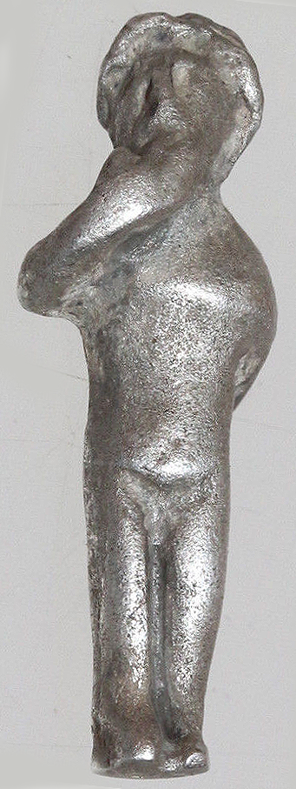 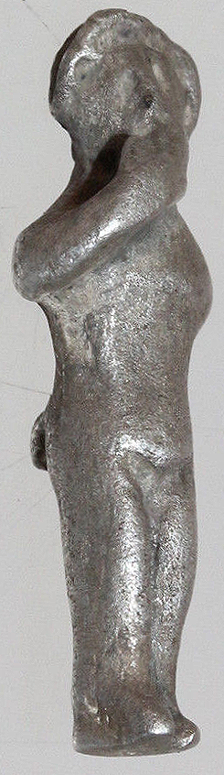 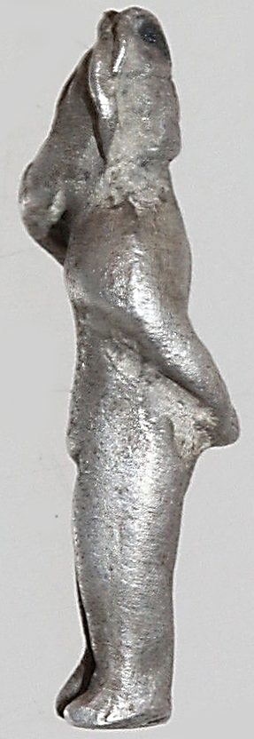 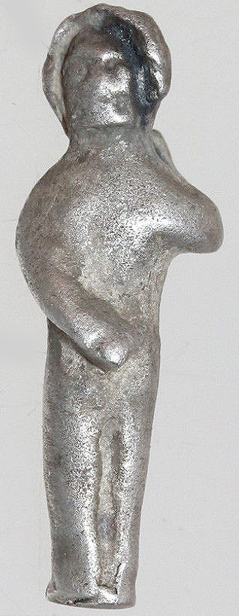

Figs. 1-4. Xian-Rome-St Peter with Halo-Right Hand to Mouth-Left Hand Behind-Silver-200 CE

**Case no.: 4**

**Accession Number:**

**Formal Label:** Xian-Rome-St Peter with Halo-Right Hand to Mouth-Left Hand Behind-Silver-200 CE

**Display Description:**

**St**. **Peter** tells us plainly what the price is. " Ye are redeemed, not with corruptible things, as silver and gold, from your vain conversation," although there was a ... but it **is not** with such perishable things as these that we are redeemed, " but with **the precious Blood of Christ**, as of a Lamb ... We can make friends by means of money, but whether such friends are always worth having it **is not** for me to **say**.

**LC Classification:**

**Date or Time Horizon:** after 64 CE

**Geographical Area:** Rome

**Map:**

**GPS coordinates:**

**Cultural Affiliation:** Roman Catholic

**Medium:** Silver

**Dimensions: H** **23 mm x W 6mm**

**Weight : 2.72gr**

**Condition:**

**Provenance:**

**Discussion:**

**References:**